http://www.unisim.edu.sg/about-unisim/Overview/PublishingImages/UniSIM_logo.gif

**BUS107**

**Quantitative Methods**

**Group Based Assignment 1**

**July 2016 Presentation**

|  |  |
| --- | --- |
| **Name** | **Student ID** |
| Lim Jia Cheng | P1603549 |
| Quek Xing Hui | Z1670051 |
| Samantha Chur Wei Wen | K1610880 |
| Lim Hui Qin | Z1610579 |

# Question 1

## Part (a)

**Step 1:** Define the Decision Variables

|  |  |
| --- | --- |
| **Variable** | **Description** |
| *x1* | Gas Lift Valve |
| *x2* | Dummy Valve |
| *x3* | Orifice Valve |
| *x4* | Safety Valve |

**Step 2:** Define the Type of Optimization Problem

This question is on maximization problem because SIM Machinery is concerned about the best profit that can be earned. In addition, profit margins for various constraints are provided.

**Step 3:** Define the Objective Function

Objective Function (*Z*) = 370*x1* + 175*x2* + 290*x3* + 300*x4*

**Step 4:** Determining the constraints

|  |  |  |
| --- | --- | --- |
| **S/N** | **Constraint Type** | **Constraint Details** |
| 1 | Performance Testing | 45*x1* + 20*x2* + 30*x3* + 25*x4* <= 2880 |
| 2 | Reliability Testing | 20*x1* + 15*x2* + 25*x3* + 10*x4* <= 1680 |
| 3 | Production for Gas lift Valve | *x1* / (*x1* + *x2* + *x3* + *x4*) <= 0.3 |
| 4 | Production for Dummy and Safety Valve | (*x2* + *x4*) / (*x1* + *x2* + *x3* + *x4*) >= 0.25 |
| 5 | Min Sales Demand Gas Lift Valve | *x1* >= 7 |
| 6 | Max Sales Demand Gas Lift Valve | *x1* <= 18 |
| 7 | Min Sales Demand Dummy Valve | *x2* >= 16 |
| 8 | Max Sales Demand Dummy Valve | *x2* <= 45 |
| 9 | Min Sales Demand Orifice Valve | *x3* >= 20 |
| 10 | Max Sales Demand Orifice Valve | *x3* <= 40 |
| 11 | Min Sales Demand Safety Valve | *x4* >= 15 |
| 12 | Max Sales Demand Safety Valve | *x4* <= 30 |

## Part (b)

Excel Solution Output:

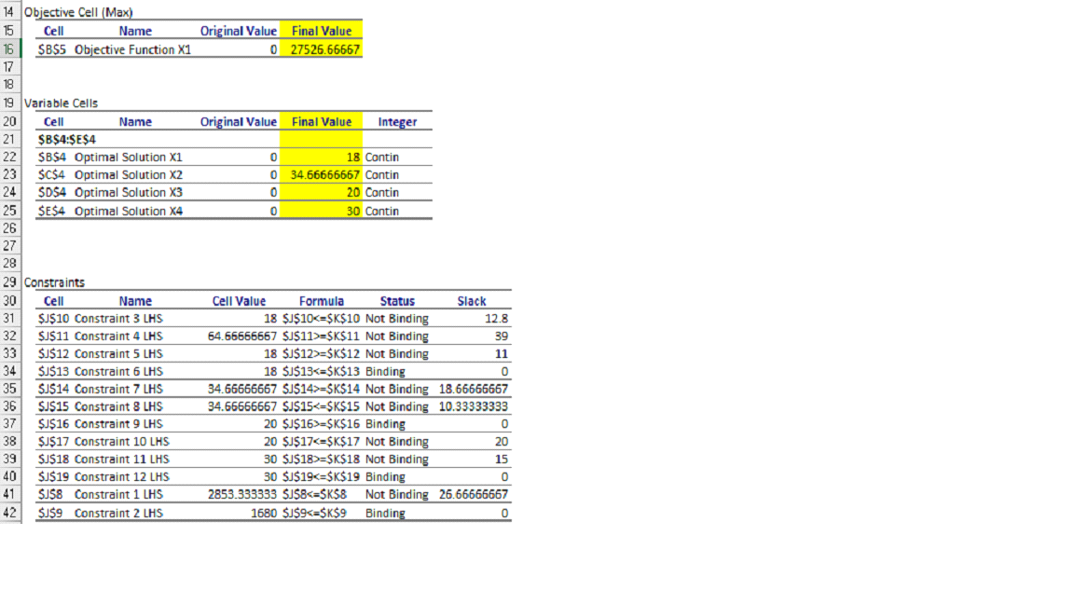

Sensitivity Output:

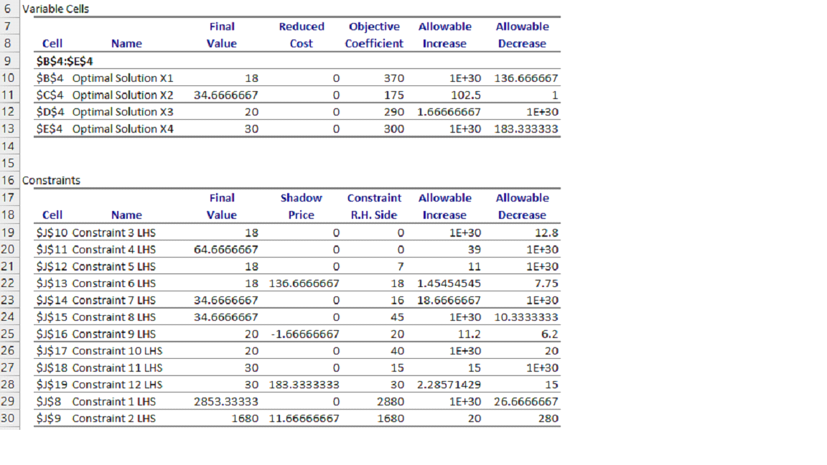

The optimal mix for the decision variables *x1,* *x2*, *x3* and *x4* are 18, 35, 20 and 30 respectively. The maximum profit which is also term it as objective function (*Z*) is $27,527 (nearest dollar).

## Part (ci)

Optimal mix will remain unchanged however the total profit will increase if the profit of Dummy Valve, represented by *x2*, increases by $10. According to the range of optimality, when the objective function coefficient increases or decreases within the acceptable range and that the other coefficient remain constant, there will be no changes to the optimal value for the decision variable.

Referring to the sensitivity output shown above, 102.5 is the allowable increase for optimal solution *x2*, therefore even with an increase of $10 would make no significant changes to the optimal solution.

## Part (cii)

**Difference in profit**

Gas Lift Valve (*x1*): 30% X 370 = 111

Safety Valve (*x4*): 30% X 300 = 90

**Allowable Decrease (based on Excel Solution Output)**

Gas Lift Valve = 136.67

Safety Valve = 183.33

**Percentage of difference against allowable decrease (based on Excel Solution Output)**

Gas Lift Valve (*x1*): 111 / 136.67 = 81.21%

Safety Valve (*x4*): 90 / 183.33 = 49.09%

Total %change: 81.2% + 49% = 130.30%

**Conclusion**

Based on the 100% rule, it is stated that switching of coefficient will not change the optimal solution if the sum of change does not exceed 100%. Based on the calculation above, the change in percentage is 130.30%, exceeding 100%. It does not comply with the 100% rule hence there is a high possibility that the optimal solution will change and the total profit will decrease.

## Part (ciii)

Difference in Reliability Testing Time: 1680min – 1480min = 2000min

Allowable Decrease (based on Excel Solution Output) = 280min

Changes in the reliability testing time will affect the price according to the range of feasibility. The difference in reliability testing time is not within the range of allowable decrease. Hence, a decrease of 200 minutes would affect the optimal solution.

# Question 2

## Part (a)

The forecasting model selected is Multiplicative Time Series Model.

The data source provided is the monthly Retail Sales Index (RSI) at current price for Telecommunication Apparatus and Computers. It measures the change of sales value, affected by fluctuation in prices and quantity, based on random sampling of retails stores. It is often used as an indicator of consumer confidence. When plotted on a linear graph, it is shown that the index peaks in the fourth quarter of every year. This indicates seasonality. Other forecasting methods such as smoothing and moving averages are not appropriate for this scenario as they do not account for the regular pattern observed.

By using Multiplicative Time Series Model to forecast the sales performance and growth for 2017, seasonal factors are taken into consideration, thus enabling a more accurate projection. First, the seasonal factors are identified and deseasonalisation takes place in order to obtain the trend line for forecasting purposes. Next, forecasted values are seasonalised accordingly to reflect the regular pattern. This ensures that the projection is reliable based on data collected from past years and that seasonality in sales are factored in the analysis. In the event where seasonality is excluded in forecasting, the results would be inaccurate as the simulation misinterpreted the past data.

## Part (b)

**Seasonal Factors**



**Deseasonalisation**



**Trend Line**

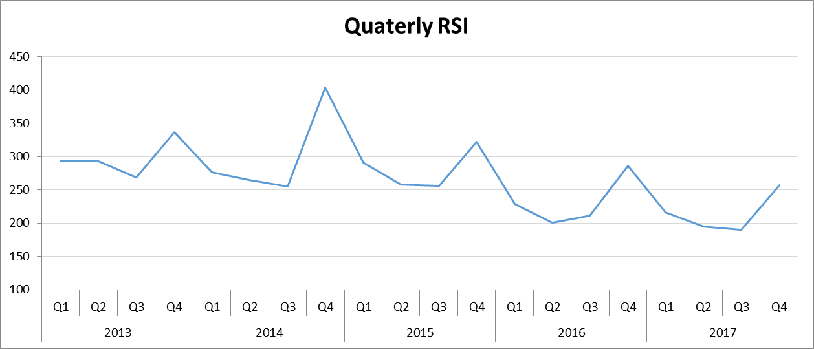

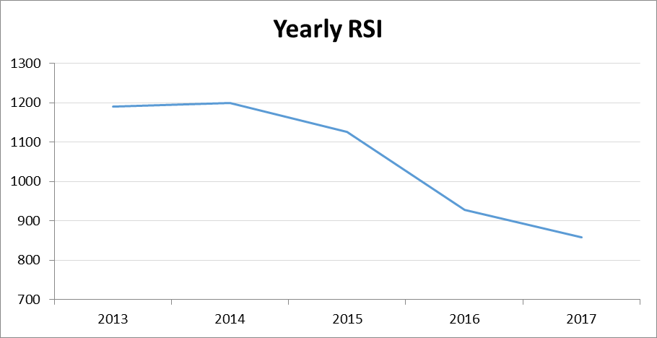

## Part (c)

Based on the chart on yearly RSI, it is observed that the index has declined greatly from 2013 to 2016, with the largest decrease between 2015 and 2016. This shows a downward trend in general for Telecommunication Apparatus and Computers in terms of the sales volume and quantity. When projected for 2017, it is natural for the index to show a continued decrease. From the projection, it is assuring to note that the dip is gradual, as compared to previous years.

Based on the chart on quarterly RSI, the seasonality is still in effect for 2017. Although RSI peaks in the fourth quarter of every year, it is noted that the regular upper limit is also falling. RSI for Q4 is about 25% increase compared to other quarters of the year. The highest percentage change is spotted in Q4 of 2014, where RSI increased by 50% approximately as compared to Q1, Q2 and Q3 in 2014.

The table below shows the project RSI for 2017 by quarters.

|  |  |
| --- | --- |
| **2017** | **RSI** |
| Q1 | 216 |
| Q2 | 195 |
| Q3 | 190 |
| Q4 | 257 |

In terms of growth strategy, the company can consider organizing marketing campaigns to promote and increase awareness for the products and services or introducing new products to the Telecommunication Apparatus and Computers market.

Marketing is a common approach in retail industry to increase sales. To counter the declining trend, it is suggested that the company organize campaigns to attract consumers. The company can attempt to lower selling price to increase the sold quantity. To do so, it should venture into sourcing suppliers that offer lower cost price. Additionally, the company can review the marketing campaigns organized in 2014 to boost the seasonal rise for 2017 Q4.

Introduction of new products to the market is another strategy the company can look at. The declining RSI from 2013 to 2016 could indicate a stagnant market. New products would be able to entice consumers and attract them to Telecommunication Apparatus and Computers. In so doing, the average RSI for 2017 might increase, thereby reviving the industry.

# Question 3

## Part (a)

**Expected Value Approach for Decision to locate operations**

|  |  |  |  |  |  |
| --- | --- | --- | --- | --- | --- |
| **Decision** | **Unchanged** | **Slightly** | **Moderate Severity** | **Severe** | **Expected Value** |
| Operate Malaysia and Vietnam plant separately. (*d1*) | $ 880,000 | $ 830,000 | $ 635,000 | $ 335,000 | $ 568,750 |
| Consolidate in Vietnam and appoint local distributors. (*d2*) | $ 900,000 | $ 855,000 | $ 625,000 | $ 315,000 | $ 563,000 |
| *Probability* | *0.1* | *0.15* | *0.35* | *0.4* |  |

Maximum expected value: $ 568,750

Recommended Decision: *d1*

**Expected Value Approach for Decision to form sole distributorship**

|  |  |  |  |  |  |
| --- | --- | --- | --- | --- | --- |
| **Scenario** | **Unchanged** | **Slightly** | **Moderate Severity** | **Severe** | **Expected Value** |
| Form joint venture with a local partner. (*d3a*) | $ 910,000 | $ 880,000 | $ 660,000 | $ 310,000 | $ 578,000 |
| Form wholly owned subsidiary. (*d3b*) | $ 915,000 | $ 875,000 | $ 630,000 | $ 325,000 | $ 573,250 |
| *Probability* | *0.1* | *0.15* | *0.35* | *0.4* |  |

Maximum expected value: $ 578,000

Recommended Decision: *d3a*

**Decision Tree**

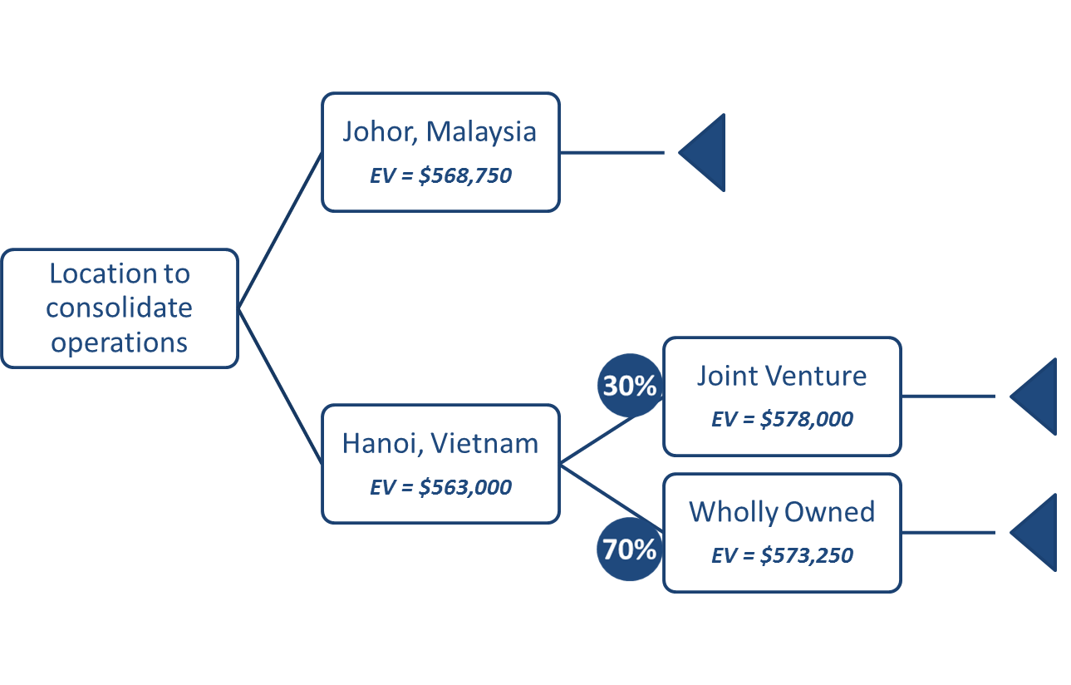

**Proposal to Management**

Advise given below is primarily based on the expected value (EV) calculated for the various scenarios.

In terms of the location to base the operations for ABC Singapore, it is advised to operate Malaysia and Vietnam plant separately as this decision generates a higher EV of $568,750. However, the difference in EV if Management were to consolidate operations in Vietnam and appoint local distributors is only $5,5750. Further analysis on the decision to form sole distributorship in Vietnam shows that joint venture with a local partner would give a higher EV of $578,000. However it should be noted that the probability of securing a reliable local partner is a low 30%.

Management can consider operating Malaysia and Vietnam plant separately and go for a joint venture with a local partner for the operations in Vietnam. This would be the better decision to take based on calculated EV. It allows ABC Singapore to hold on to existing and potential customers in Malaysia while venturing into the Indochina market.

## Part (b)

Expected value of perfect information (EVPI) refers to the increase in expected profit that would result from the knowledge of outcome that would occur. It is calculated as the difference between Expected value with perfect information and Maximum expected value.

**Expected value of Perfect Information**

|  |  |  |  |  |  |
| --- | --- | --- | --- | --- | --- |
| **Scenario** | **Unchanged** | **Slightly** | **Moderate Severity** | **Severe** | **Expected Value w/PI** |
| Maximum Payoff | $ 915,000 | $ 880,000 | $ 660,000 | $ 325,000 | $ 584,500 |
| *Source* | *d3b* | *d3a* | *d3a* | *d3b* |  |
| *Probability* | *0.1* | *0.15* | *0.35* | *0.4* |  |

Maximum expected value: $ 578,000

Expected value of perfect information (EVPI): $ 6,500

From the results above, the EVPI is an increase of $6,500 where perfect information is available. When it is known with certainty what the maximum payoff is across various decisions, the Expected value with perfect information ($584,500) and Maximum expected value ($578,000) can be determined. This shows that decision made with or without perfect information has an impact of $6,500. However, it should be noted that in real life scenario, it is unlikely for one to have perfect information or be aware for certain the decisions and associated outcome.